From: Pavlov Dmitriy Stanislavovich
Sent: Monday, November 02, 2015 12:30 PM
To: Belogrud Sergey Vladimirovich
Cc: Leonov Aleksey Vladimirovich
Subject: RE: [SD] (№597555) В запрос где вы ответственный добавлен комментарий

Да, можно закрывать, думаю.

From: Belogrud Sergey Vladimirovich
Sent: Monday, November 02, 2015 11:25 AM
To: Pavlov Dmitriy Stanislavovich
Cc: Leonov Aleksey Vladimirovich
Subject: RE: [SD] (№597555) В запрос где вы ответственный добавлен комментарий

Добрый день.

Из имеющихся данных, я понимаю, что так.
Заявку SD#597555 закрываю?

Замечу, что среди имеющихся совместимых «Riser Kit», только один согласуется по количеству слотов и их типу с полученной с серверов информацией.
Это 500579-B21, о котором и имеется подробная информация.

From: Pavlov Dmitriy Stanislavovich
Sent: Sunday, November 01, 2015 2:26 PM
To: Belogrud Sergey Vladimirovich
Cc: Leonov Aleksey Vladimirovich
Subject: RE: [SD] (№597555) В запрос где вы ответственный добавлен комментарий

Итого, по словам HP у нас там x8, в котором разведен x4. Правильно?
Если да, то экспандеры не нужны, закупку можно отменять.

From: Belogrud Sergey Vladimirovich
Sent: Friday, October 30, 2015 8:10 PM
To: Pavlov Dmitriy Stanislavovich
Cc: Leonov Aleksey Vladimirovich
Subject: RE: [SD] (№597555) В запрос где вы ответственный добавлен комментарий

+Leonov

From: Belogrud Sergey Vladimirovich
Sent: Friday, October 30, 2015 8:08 PM
To: Pavlov Dmitriy Stanislavovich
Subject: RE: [SD] (№597555) В запрос где вы ответственный добавлен комментарий

Так я что-то не пойму, что у вендора спросить?
Вендор имеется в виду – HP?

Представитель вендора написал в чате, что для стандартного «Riser Kit» физическая конфигурация интерфейсов такая:
Один длиннющий – это 1x16 с пропускной способностью шины x8;
И два покороче – это 2x8 спропускной способностью шина x4.

В наших серверах-сегментах ds-gp-dev свободен разъём с пропускной способностью шины x4 – следовательно физически это тот интерфейс, что покороче.
Так что же спросить у представителя вендора – у нас точно внутри серверов установлен стандартный «Riser Kit»? J
Напрашивается автоответ – а не посмотрели-бы Вы сами внутрь своих серверов… J Разве нет?

Или я всё не так понял?

From: R, Nayan Kumar [mailto:nayan-kumar.r@hpe.com]
Sent: Friday, October 30, 2015 2:51 PM
To: Belogrud Sergey Vladimirovich
Cc: Hpsupport_Global
Subject: <CASE:4652659166>

Dear Sergey,

Thank you for contacting HP Chat Support.

Below is the summary of our interaction on Chat

Case ID: 4652659166
Product: HP ProLiant DL380 G7 Server
Issue reported: PCI riser part details.

Please find the compatible PCI riser part details.

HP DL380G6/G7 PCI-E 1x8 2x4 Riser Kit - 500579-B21

This card has 3 slots
1 x16 slot and 2 x8 slot
slot 1 - Full Length, Full Height | bus width x8
slot 2 - Half Length, Full Height | bus width x4
slot 3 - Half Length, Full Height | bus width x4

For more details - http://www8.hp.com/h20195/v2/getpdf.aspx/c04199811.pdf?ver=40
Page - 4 – standard

Page - 24 for part number under HP Unique Options

Other part options.

1. HP DL38X PCI-X riser Kit (1) PCI-X, (1) x8, (1) x4)
1 pcix - 1 x8 and 1 x4 slot
494322-B21

2. HP DL38X (1) x16 PCI-E riser Kit
1 x16 slot
494323-B21

3. HP DL38X (2) x8 PCI-E Riser Kit
2 x8 slots
494326-B21

I hope your query has been addressed to your satisfaction.

If you need any further assistance please reply to this e-mail.

You may also get back to us on chat for further support. We are available 24x7 at www.hp.com/go/hpchat .

Thank you for contacting HP!

Regards,
Nayan Kumar R
Technical Solutions Consultant
TS GSD CSCB
ESSN - Industry Standard Servers
Hewlett-Packard Enterprise

My hours of availability are: 18:30-03:30 IST (+5:30 GMT) (Mon -Fri)
Please contact us at:
1. Chat support: www.hp.com/go/hpchat
2. E-mail support: www.hp.com/go/hpsc
3. Phone Support: http://www8.hp.com/us/en/contact-hp/ww-contact-us.html

ds-gp-dev-sdw1
Handle 0x0901, DMI type 9, 17 bytes
Designation: PCI-E Slot 1
Type: x8 PCI Express
Current Usage: In Use
Bus Address: 0000:08:00.0
Handle 0x0902, DMI type 9, 17 bytes
Designation: PCI-E Slot 2
Type: x4 PCI Express
Current Usage: Available
Bus Address: 0000:0b:00.0
Handle 0x0903, DMI type 9, 17 bytes
Designation: PCI-E Slot 3
Type: x4 PCI Express
Current Usage: In Use
Bus Address: 0000:0e:00.0
Connection to sdw1 closed.

ds-gp-dev-sdw2
Handle 0x0901, DMI type 9, 17 bytes
Designation: PCI-E Slot 1
Type: x8 PCI Express
Current Usage: In Use
Bus Address: 0000:08:00.0
Handle 0x0902, DMI type 9, 17 bytes
Designation: PCI-E Slot 2
Type: x4 PCI Express
Current Usage: Available
Bus Address: 0000:0b:00.0
Handle 0x0903, DMI type 9, 17 bytes
Designation: PCI-E Slot 3
Type: x4 PCI Express
Current Usage: In Use
Bus Address: 0000:0e:00.0
Connection to sdw2 closed.

ds-gp-dev-sdw3
Handle 0x0901, DMI type 9, 17 bytes
Designation: PCI-E Slot 1
Type: x8 PCI Express
Current Usage: In Use
Bus Address: 0000:08:00.0
Handle 0x0902, DMI type 9, 17 bytes
Designation: PCI-E Slot 2
Type: x4 PCI Express
Current Usage: Available
Bus Address: 0000:0b:00.0
Handle 0x0903, DMI type 9, 17 bytes
Designation: PCI-E Slot 3
Type: x4 PCI Express
Current Usage: In Use
Bus Address: 0000:0e:00.0
Connection to sdw3 closed.

ds-gp-dev-sdw4
Handle 0x0901, DMI type 9, 17 bytes
Designation: PCI-E Slot 1
Type: x8 PCI Express
Current Usage: In Use
Bus Address: 0000:08:00.0
Handle 0x0902, DMI type 9, 17 bytes
Designation: PCI-E Slot 2
Type: x4 PCI Express
Current Usage: Available
Bus Address: 0000:0b:00.0
Handle 0x0903, DMI type 9, 17 bytes
Designation: PCI-E Slot 3
Type: x4 PCI Express
Current Usage: In Use
Bus Address: 0000:0e:00.0
Connection to sdw4 closed.

ds-gp-dev-sdw5
Handle 0x0901, DMI type 9, 17 bytes
Designation: PCI-E Slot 1
Type: x8 PCI Express
Current Usage: In Use
Bus Address: 0000:08:00.0
Handle 0x0902, DMI type 9, 17 bytes
Designation: PCI-E Slot 2
Type: x4 PCI Express
Current Usage: Available
Bus Address: 0000:0b:00.0
Handle 0x0903, DMI type 9, 17 bytes
Designation: PCI-E Slot 3
Type: x4 PCI Express
Current Usage: In Use
Bus Address: 0000:0e:00.0
Connection to sdw5 closed.

ds-gp-dev-sdw6
Handle 0x0901, DMI type 9, 17 bytes
Designation: PCI-E Slot 1
Type: x8 PCI Express
Current Usage: In Use
Bus Address: 0000:08:00.0
Handle 0x0902, DMI type 9, 17 bytes
Designation: PCI-E Slot 2
Type: x4 PCI Express
Current Usage: Available
Bus Address: 0000:0b:00.0
Handle 0x0903, DMI type 9, 17 bytes
Designation: PCI-E Slot 3
Type: x4 PCI Express
Current Usage: In Use
Bus Address: 0000:0e:00.0
Connection to sdw6 closed.

ds-gp-dev-sdw7
Handle 0x0901, DMI type 9, 17 bytes
Designation: PCI-E Slot 1
Type: x8 PCI Express
Current Usage: In Use
Bus Address: 0000:08:00.0
Handle 0x0902, DMI type 9, 17 bytes
Designation: PCI-E Slot 2
Type: x4 PCI Express
Current Usage: Available
Bus Address: 0000:0b:00.0
Handle 0x0903, DMI type 9, 17 bytes
Designation: PCI-E Slot 3
Type: x4 PCI Express
Current Usage: In Use
Bus Address: 0000:0e:00.0
Connection to sdw7 closed.

ds-gp-dev-sdw8
Handle 0x0901, DMI type 9, 17 bytes
Designation: PCI-E Slot 1
Type: x8 PCI Express
Current Usage: In Use
Bus Address: 0000:08:00.0
Handle 0x0902, DMI type 9, 17 bytes
Designation: PCI-E Slot 2
Type: x4 PCI Express
Current Usage: Available
Bus Address: 0000:0b:00.0
Handle 0x0903, DMI type 9, 17 bytes
Designation: PCI-E Slot 3
Type: x4 PCI Express
Current Usage: In Use
Bus Address: 0000:0e:00.0
Connection to sdw8 closed.

Занятые разъёмы это:
08:00.0 RAID bus controller: Hewlett-Packard Company Smart Array G6 controllers (rev 01)
0e:00.0 Ethernet controller: Emulex Corporation OneConnect 10Gb NIC (rev 02)

From: Pavlov Dmitriy Stanislavovich
Sent: Friday, October 30, 2015 4:18 PM
To: Belogrud Sergey Vladimirovich
Subject: RE: [SD] (№597555) В запрос где вы ответственный добавлен комментарий

В четверг удалось выяснить следующее:
Оба типа карт используют интерфейс x4, однако в старом типе этот интерфейс выведен в аппаратную колодку х8. Так что на данный момент вопрос в следующем:
Какой именно физический интерфейс PCI свободен в ген7 серверах - есл– действительно x8 (который на самом деле x4) – то экспандеры не нужны, если же x4 – экспандеры нужны.
Если есть возможность, просьба уточнить у вендора ширину разъёма.

From: Belogrud Sergey Vladimirovich
Sent: Friday, October 30, 2015 3:54 PM
To: Pavlov Dmitriy Stanislavovich
Subject: RE: [SD] (№597555) В запрос где вы ответственный добавлен комментарий

Доброй пятницы.

Однако четверг минул.

From: Pavlov Dmitriy Stanislavovich
Sent: Tuesday, October 27, 2015 5:21 PM
To: Belogrud Sergey Vladimirovich
Subject: RE: [SD] (№597555) В запрос где вы ответственный добавлен комментарий

Привет, оставь наверно пока, в чт решим

From: Belogrud Sergey Vladimirovich
Sent: Tuesday, October 27, 2015 5:17 PM
To: Pavlov Dmitriy Stanislavovich
Subject: RE: [SD] (№597555) В запрос где вы ответственный добавлен комментарий

Привет.

Быстро-вопрос:

Дата | Комментарий | Автор
27.10.2015 11:18 | Эту задачу закрывать? | Белогруд Сергей В
27.10.2015 10:27 | Пока тормозим процесс поиска и закупки - вроде как нам хватит одного x4 разъёма. | Павлов Дмитрий

From: Service Desk
Sent: Tuesday, October 27, 2015 10:28 AM
To: Belogrud Sergey Vladimirovich
Subject: [SD] (№597555) В запрос где вы ответственный добавлен комментарий

Изменения
Автор комментария | Павлов Дмитрий
Описание комментария | Пока тормозим процесс поиска и закупки - вроде как нам хватит одного x4 разъёма.
Информация по запросу
Номер запроса | 597555
Дата регистрации | 21.10.2015 13:05
Тип запроса | Запрос на обслуживание
Инициатор | Павлов Дмитрий
Критичность | Низкая
Краткое описание | Закупить PCI экспандеры для HP DL380 Gen7
Описание запроса | Добрый день.  Задачу на unix-admins.  Компания HGST согласилась предоставить нам на тестирование 8 PCI SSD карт, а именно: 4-6 штук новейших NVMe карточек SN150 и 2-4 карты предыдущего поколения FlashMax III.  Необходимо обеспечить установку карт в DEV DS контур Greenplum (8 HP DL380 gen7). Для этого понадобится закупить и установить 8 PCI Riser cards:  http://www.itechdevices.com/500579-b21-hp-dl380-g6-pci-e-riser-option-kit/  [http://cdn2.bigcommerce.com/n-arxsrf/vqv036/products/767/images/4468/500579_B21__78485.1390828368.1280.1280.jpg?c=2]  Как выглядят PCI-карты (для обеих карт есть как полные, так и маленькие задние брэкеты):  SN-150:  [http://pics.computerbase.de/6/4/3/1/5/1-1080.2473475713.jpg]  Flashmax 3:  [http://www.ixbt.com/short/images/2014/Aug/Untitled-1_004.jpg]  С уважением,  Дмитрий Павлов  Руководитель группы администрирования DWH

20151022
# Here is my chat with HP customer support.
# I have used information, that was taken from ds-gp-dev-sdw1.
https://h20565.www2.hpe.com/portal/site/hpsc/public/psi/home/?sp4ts.oid=4091412&sp4ts.sn=CZ3236VT8Y&sp4ts.pn=583914-B21

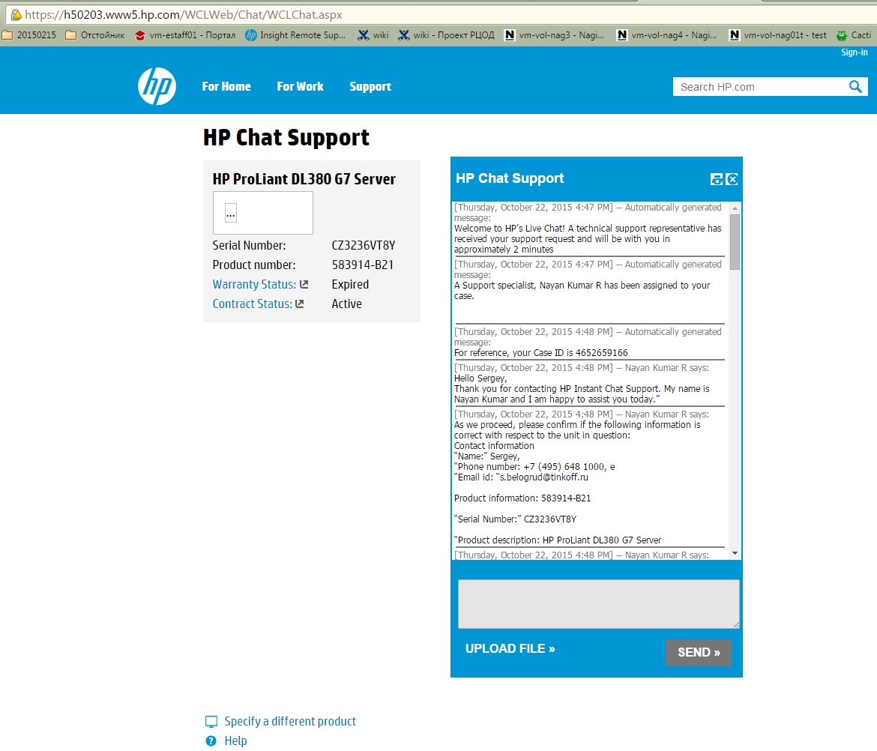

[Thursday, October 22, 2015 4:47 PM] -- Automatically generated message:
Welcome to HP’s Live Chat! A technical support representative has received your support request and will be with you in approximately 2 minutes
[Thursday, October 22, 2015 4:47 PM] -- Automatically generated message:
A Support specialist, Nayan Kumar R has been assigned to your case.

[Thursday, October 22, 2015 4:48 PM] -- Automatically generated message:
For reference, your Case ID is 4652659166
[Thursday, October 22, 2015 4:48 PM] -- Nayan Kumar R says:
Hello Sergey,
Thank you for contacting HP Instant Chat Support. My name is Nayan Kumar and I am happy to assist you today.”
[Thursday, October 22, 2015 4:48 PM] -- Nayan Kumar R says:
As we proceed, please confirm if the following information is correct with respect to the unit in question:
Contact information
“Name:” Sergey,
“Phone number: +7 (495) 648 1000, e
“Email id: “s.belogrud@tinkoff.ru

Product information: 583914-B21

“Serial Number:” CZ3236VT8Y

“Product description: HP ProLiant DL380 G7 Server
[Thursday, October 22, 2015 4:48 PM] -- Nayan Kumar R says:
Please let me know the server location (Country) and alternate phone number - if available
[Thursday, October 22, 2015 4:49 PM] -- Sergey Belogrud says:
Hello Nayan Kumar.
I confirm that all of information that you have written above is correct.
[Thursday, October 22, 2015 4:49 PM] -- Nayan Kumar R says:
Thank you for confirming the above information.
[Thursday, October 22, 2015 4:49 PM] -- Nayan Kumar R says:
Please let me know the server location (Country) and alternate phone number - if available
[Thursday, October 22, 2015 4:49 PM] -- Sergey Belogrud says:
The server is located in Russia. I have no alternative phone number.
[Thursday, October 22, 2015 4:51 PM] -- Nayan Kumar R says:
As I understand you would like to know the part details for compatible part details for pci riser for your servr.
[Thursday, October 22, 2015 4:51 PM] -- Nayan Kumar R says:
Is that correct.
[Thursday, October 22, 2015 4:51 PM] -- Sergey Belogrud says:
That's right. Exactly.
[Thursday, October 22, 2015 4:52 PM] -- Nayan Kumar R says:
Please allow me 4-5 minutes to locate these details for your HP ProLiant DL380 G7 Server
[Thursday, October 22, 2015 4:53 PM] -- Sergey Belogrud says:
I have read "QuickSpecs" of "HP ProLiant DL380 Generation 7". And found that there are several of types of these riser card available.
[Thursday, October 22, 2015 4:54 PM] -- Sergey Belogrud says:
But I have no found Part Number or something, that identify it.
[Thursday, October 22, 2015 4:57 PM] -- Sergey Belogrud says:
Inside our servers we already have installed one of similar riser card. It uses for PCI card of raid controller. On these server we have installed Linux OS, and I can send you sove necessary information.
[Thursday, October 22, 2015 4:59 PM] -- Sergey Belogrud says:
Unfortunately, I cannot open up one of these server and see inside it with my eyes. These servers are locate in DataCenter that not close to me.
[Thursday, October 22, 2015 5:00 PM] -- Nayan Kumar R says:
Sure, not a problem.
[Thursday, October 22, 2015 5:02 PM] -- Nayan Kumar R says:
HP DL380G6/G7 PCI-E 1x8 2x4 Riser Kit
[Thursday, October 22, 2015 5:02 PM] -- Nayan Kumar R says:
500579-B21
[Thursday, October 22, 2015 5:02 PM] -- Nayan Kumar R says:
This is the part number for the standard pci riser kit for your server.
[Thursday, October 22, 2015 5:02 PM] -- Sergey Belogrud says:
Big thanks. :-)
[Thursday, October 22, 2015 5:02 PM] -- Nayan Kumar R says:
This card has 3 slots
[Thursday, October 22, 2015 5:03 PM] -- Nayan Kumar R says:
1 x16 slot and 2 x8 slot
[Thursday, October 22, 2015 5:03 PM] -- Nayan Kumar R says:
slot 1 - Full Length, Full Height
[Thursday, October 22, 2015 5:03 PM] -- Nayan Kumar R says:
slot 1 - Half Length,Full Height
[Thursday, October 22, 2015 5:04 PM] -- Nayan Kumar R says:
Please ignore previous.

slot 1 - Full Length, Full Height
slot 2 - Half Length,Full Height
slot 3 - Half Length,Full Height
[Thursday, October 22, 2015 5:05 PM] -- Nayan Kumar R says:
slot 1 - bus width x8
slot 2 - bus width x4
slot 3 - bus width x4
[Thursday, October 22, 2015 5:05 PM] -- Nayan Kumar R says:
For more details -http://www8.hp.com/h20195/v2/getpdf.aspx/c04199811.pdf?ver=40
Page - 4 - standard
[Thursday, October 22, 2015 5:06 PM] -- Nayan Kumar R says:
Page - 24 for part number under HP Unique Options
[Thursday, October 22, 2015 5:07 PM] -- Sergey Belogrud says:
Ok, ok.
You have said "standard", is it exists non standard?
It's just to know. If this information is difficult to find out - it's need not to find it by you.

I think that information, that you already have written to me is complete and enough.
[Thursday, October 22, 2015 5:08 PM] -- Nayan Kumar R says:
1. HP DL38X PCI-X riser Kit (1) PCI-X, (1) x8, (1) x4)
494322-B21

2. HP DL38X (1) x16 PCI-E riser Kit
494323-B21

3. HP DL38X (2) x8 PCI-E Riser Kit
494326-B21
[Thursday, October 22, 2015 5:08 PM] -- Nayan Kumar R says:
These are other options for pci riser for this server.
[Thursday, October 22, 2015 5:09 PM] -- Nayan Kumar R says:
Card 1 - 1 pcix - 1 x8 and 1 x4 slot
Card 2 - 1 x16 slot
Card 3 - 2 x8 slots
[Thursday, October 22, 2015 5:10 PM] -- Nayan Kumar R says:
You may choose the riser based on your requirements.
[Thursday, October 22, 2015 5:10 PM] -- Sergey Belogrud says:
Excellent.
Your information are very helpful for me!
Thank you so much!
[Thursday, October 22, 2015 5:10 PM] -- Sergey Belogrud says:
That exactly what I need.
[Thursday, October 22, 2015 5:11 PM] -- Nayan Kumar R says:
You are welcome.
[Thursday, October 22, 2015 5:11 PM] -- Nayan Kumar R says:
May I know if there is anything else I may assist you with as of now regarding your server.
[Thursday, October 22, 2015 5:13 PM] -- Sergey Belogrud says:
At this moment I have no idea for further questions. I have received everything what I want. And even more. :-)
[Thursday, October 22, 2015 5:14 PM] -- Nayan Kumar R says:
It was my pleasure assisting you today.
[Thursday, October 22, 2015 5:15 PM] -- Nayan Kumar R says:
To be able to serve you better, do help by sharing your valuable feedback with us.

We would appreciate if you do spare a moment and share a written feedback with my Manager (Bibhuti Bhusan Mishra / mail to - bibhuti-bhusan.mishra@hpe.com) on the support provided by me today.
[Thursday, October 22, 2015 5:15 PM] -- Nayan Kumar R says:
“At HP, we strive to deliver outstanding service every time and to ensure that the support experience is excellent; we would like to gather your feedback through our Customer survey. You may receive a survey invitation from hp.supportsurvey@hp.com. Please feel free to share your experience or comments with us.

Also note for any complaints with our services, please send an email to cers@hp.com. It will be responded to in an hour.

should you need any assistance in the future, please feel free to contact our instant chat support team and we would be glad to assist you.

Thank you for choosing HP.
You have a great day.”
[Thursday, October 22, 2015 5:16 PM] -- Sergey Belogrud says:
I will keep this chat window to copy some info from it if it don't disturb you.
Thanks again and bye-bye.
Good luck.

http://www8.hp.com/h20195/v2/getpdf.aspx/c04199811.pdf?ver=40

HP ProLiant DL380 G7 Server - Option Parts
https://h20565.www2.hpe.com/hpsc/doc/public/display?calledBy=Search_Result&docId=emr_na-c02755440&docLocale=en_US

